I’ll start this report by showing the raw data for each of the treatments, without bootstrapping or any other manipulation.
Treatment | n | Successes | Success Rate
Lifestyle | 234 | 125 | .534
Met | 232 | 112 | .483
Rosi | 233 | 143 | .614
Based on the raw data alone, rosi has the highest success rate of the three treatments at 61.4%. Lifestyle changes also have a positive success rate at 53.4%, and met is the only treatment to have a negative success rate at 48.3%. I think this is a good place to start for exploratory analysis, but I wanted to see if the raw data would hold up under more scrutiny. To that end, here is the KDE and ECDF of the sample, bootstrapped 10,000 times.
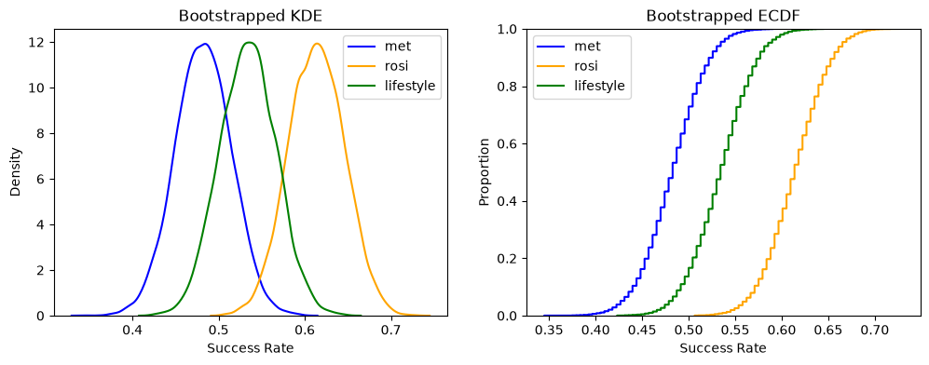
The KDE and ECDF tell the same story as the raw data – rosi is the best treatment, met is the worst treatment, and lifestyle changes are somewhere in the middle. The fact that there isn’t any overlap whatsoever in the ECDF is rather convincing as well, as there is no point in the proportion where lifestyle changes aren’t better than met and no point where rosi isn’t better than lifestyle changes. The KDE does show a bit of overlap between the three treatments, but the density peaks for the three treatments’ success rates remain consistent with the raw data and the ECDF.
To be more certain about the significance of the differences between the treatments, I constructed 90/95/99 confidence intervals. Here is the table, including both the confidence intervals and the overall estimate for the differences between each different treatment combination (met and rosi, met and lifestyle changes, and rosi and lifestyle changes).
Comparison | Interval | Estimate | Lower | Upper
Met – rosi | 90 | -.1314 | -.2083 | -.0578
Met – rosi | 95 | -.1314 | -.2212 | -.0407
Met – rosi | 99 | -.1314 | -.2473 | -.0148
Met – lifestyle | 90 | -.0518 | -.1286 | .0257
Met – lifestyle | 95 | -.0518 | -.1418 | .0388
Met – lifestyle | 99 | -.0518 | -.1719 | .0645
Rosi – lifestyle | 90 | .0796 | .0026 | .1525
Rosi – lifestyle | 95 | .0796 | -.0104 | .1695
Rosi – lifestyle | 99 | .0796 | -.0362 | .1953

The confidence intervals paint a far murkier picture for the significance of the different treatments than the raw data and the ECDF do. The most convincing difference is between met and rosi, as 0 is not part of any of the three intervals for that treatment comparison. This would mean the difference between the two treatments is significant, and the difference in this case is negative – met is worse than rosi in some capacity. The only other interval among the treatment comparisons that doesn’t include 0 is the 90% interval of the rosi and lifestyle changes comparison, which would indicate that rosi is significantly better than lifestyle changes. However, 0 is included in the 95% and 99% intervals for this treatment comparison, which raises the question of how precise we want our significance to be. In this case, considering we’re discussing prevention of a serious disease like diabetes, I would lean towards the more stringent 95% and 99% intervals, meaning I wouldn’t confidently say that there’s a significant difference between rosi and lifestyle changes.
Overall, it remains true that rosi seems to be the best treatment option, based on the combination of the raw data, KDE/ECDF, and the confidence intervals with an overall estimated difference. That being said, we cannot confidently say that rosi is significantly better than lifestyle changes because of the inclusion of 0 in the more stringent confidence intervals and can thus only confidently conclude that rosi is better than met. My recommendation for future trials would be to only compare rosi and lifestyle changes, ideally with a larger sample size, to see if we can observe a significant difference between the two treatments. If we cannot detect that, there may be merit to recommending some patients to resort to lifestyle changes instead of taking rosi, considering the likely cost affiliated with the drug as well as any potential side effects.

